Meeting Minutes #3

Date/Time | : | 25th March 2003 | [08:00 – 10:00]
Venue | : | Penjuru Conference Room
Attendees | : | KW Chin, Eway Lee, Christopher Lim, Darren Lee, Yeo Boon Chuah, Hermawan Christanto, Edwin Ong, Ong Ning Shern & Charles Phoon
Absentees | : | Soh Chui Yin & William Lim

Order of Priority | Causes | Owner / Action | Status
1 [22/03/03] | Inventory Integrity  - migration from Red to Blue system - HP PO issues, migration list  - definition of red / blue item list  - no cycle count to date  - incorrect supplier inventory | Edwin Ong  - Work with HP buyers  - Map out cycle process (physical count & recon)  - Form cycle count team  - Perform daily count; priority on HOI/COI | effective 22-Mar-03  Status Update [24/03/03]  - HOI System to System matches  - HOI Physical & System has a gross discrepancies of about 30%  - HOI Discrepancies are now in the blocked bucket  - SOI not counted yet  Status Update [25/03/03]  - Completed the HOI Count for HPAM  - 2pcs missing from Floor 5  - Edwin to publish the Cycle Count Results for HPAM & Penjuru to HP.  - Darren to provide the vendors' expectations on the Stock Status, follow-up action, etc  - Pending confirmation on the wall-to-wall count on 01-02/04/03. However, Edwin/NingShern/Charles to work out the procedure & resource for the wall-to-wall count to be discussed on 26/03/03.
2 [22/03/03] | Manpower  - Over-stretched resources  - Low morale  - Unskilled / Untrained Staff | Yeo – Work out manpower schedule; immediate support requirements  Chris  - Boost staff morale; Daily meeting with key staff.  - Ensure Sup/mgr to train staff from other programs/temp help  Joyce - Look into staff welfare / improve staff morale | Status Update [24/03/03]  - To be submitted by 24/03/03  Status Update [25/03/03]  - To submit according to the attached format by 25/03/03
3 [22/03/03] | Communication & Co-ordination  - Between HPAM & G7 | Yeo to bridge communication and assist in internal co-ordination | Effective 22-Mar-03  Status Update [24/03/03]  - To improve the connectivity between G7 & G9.  - Chris - To work on the processes between issuing by G7 & receiving by G9 to tighten the process on the physical move of parts and to reduce any redundant work steps.  Status Update [25/03/03]  In-placed.
4 [22/03/03] | Process  - Biz & operational process  - Biz Rules | Chris & Darren - establish biz rules with HP and evaluate processes
5 [22/03/03] | Roles & Responsibility  - No clear definition on roles & responsibilities | Chin - refer to new Operating Council | effective 22-Mar-03
6 [22/03/03]  * Changed to Top Priority | Order drop pattern / order size / order pull  - order size - too small for production but too large for option  - selective order for production pull  - poor utilization of transportation due to smaller order lot (some unstackable) | Hermawan / Charles- study order trend & analysis, capacity; determine optimum staffing; assess operating processes | Status Update [24/03/03]  - Changed to Top Priority  - Managing the order dropped pattern and how the orders are fulfilled, including any obstacles hindering, priority of orders, order relation.  - Yeo / SengHock / Hermawan - To do a study and identify how to prioritise the orders to be fulfilled.  Status Update [25/03/03]  - Overall Process approved [see attached process]  - Internal Store sorting by Production TR. In future, to look into order fulfillment by external store to be kit to Production TR.  - Hermawan / Charles to confirm on any consolidation rules for the Production TR.  - The current monitoring system to be replaced only after 01/04/03. Hermawan / Charles to work with IT to develop a common platform to be launched on 01/04/03.  - Chris to communicate the process to the Ops Managers, Co-ordinators and Supervisors.  - Chris to arrange for training for the parties involved.
7 [22/03/03] | IT  - system slowness both SAP 3.1 & WMS  - archiving & maintenance which slow down system performance (2am to 4am daily)  - lack of order visibility for reporting to HP & internal use | Collin - look into solution / study more effective way of daily archiving; feasibility study on SQL2000 migration; report issues to HP IT  Opns - report problem to BAX on-site IT personnel at the pt of occurrence  Chris - define report requirements  Collin/Henry – Develop reports and submit request to HP IT (if required)
8 [22/03/03] | Infrastructure (G7)  - No designated area (work space & non-workspace)  - Insufficient work station (can be IT equipt, work benches, chairs)  - Power failure; no power backup  - Poor working environment (heat / sound/ air pollution) | Hermawan & Charles - study material flow; defined work areas; put up signages  Yeo - define requirements  Albert - work with CNP on backup power generator;  Albert - install industrial fan and exhaust fan; look into security and EHS issues; recommend more ideal location for human activities [Completed in mid Apr 03]
9 [22/03/03] | External Pressure – HP & Suppliers  - Use of unrefined language; affect staff morale  - Hostile conversation | BAX mgmt (Chin / Charlie) - address issue with external parties
10 [24/03/03] | Physical quantity and what is indicated on the face value needs to be verified. | Darren - To investigate the incident. To establish the procedure & process to handle the discrepancies, as well as operational process to close the gap.
11 [24/03/03] | Tracking of Truck Movement, Status, TAT, parts discrepancies | Chris / Yeo - To produce the format for this purpose | Status Update [25/03/03]  - To use the presented format up till 31/03/03. The proposed format presented together with the overall process flow to be adopted.

OBJECTIVE: Maintain HP production line continuity and meet expected TAT
HP's Expected TAT
(A) Issuing
 | ISSG/ESG: |  | 2hrs (1st order drop at 0700hrs / 1st TAT 4hrs, subsequent 2hrs)
 | PSG: |  | 2hrs
 | Alpha: |  | 6hrs
 | MMR: |  | 24hrs
 | Alpha Option: |  | 24hrs
 | ESG Option diskdrive: |  | 24hrs
 | ESG Option: |  | 24hrs
 | ISSG Option (incl hard disk): |  | 24hrs (need scanning)
 | PSG Option hard disk: |  | 24hrs (need scanning)
 | PSG Option: |  | 24hrs
Actual performance: 3.5hr at best / Sometimes HP experiences production line down
(B) Receiving
 | 1 hour from dock time to system stock time (for all receipts)
Actual performance: majority exceed 1hr

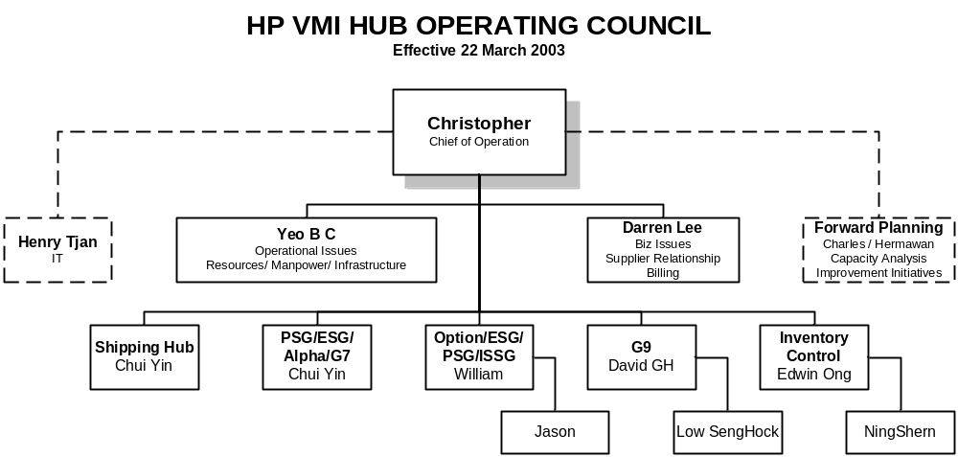

Effective 1st April 03: Andrew Lim will assist Chui Yin in Shipping Hub

Overall Manpower Schedule for the HP Program

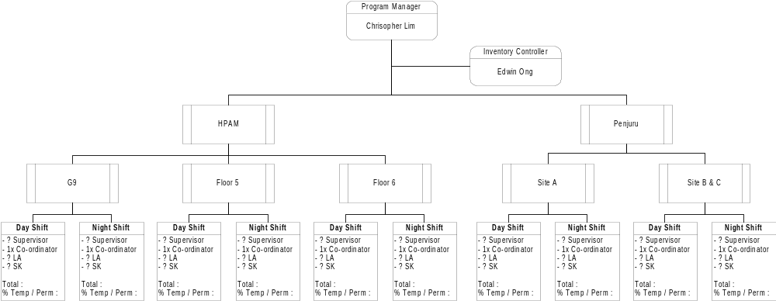

Common Status Monitoring Chart

FRONT END / BACK END / OPTION
Date | Production TR | Time Received | Master TR | FrontEnd / BackEnd / Option | Location TR | Location | Sequence | TR Finish Processing Time by Int Store | Ready To Despatch |  | Delivery Activation Time | Date/ Time Goods Arrived |  |  |  | H/O To Prod Time | REMARKS
 |  |  |  |  |  |  |  |  | Target Time | Actual Time
24-Mar-03 | 11 | 0900 | 21 |  | 211 | G71 | 1 (BATCH 1) | 0915 | 1015 | 1100 | 1100 | 1200 |  |  |  | 1400 | System down for 30 mins
 | 12 |  |  |  | 212 | G72 |  |  | 1015 | 1010 | 1015 | 1030
 | 13 |  |  |  | 213 | G7A |  |  | 1015 | 0945 | NA | 0945
 | 14 |  |  |  | 214 | G7B |  |  | 1015 | 1015 | NA | 1015
 | 15
 | 16
24-Mar-03 | 21 | 1200 | 22 |  | 221 | G71 | 2 (BATCH 2) | 1220 | 1320 | 1300
 | 22 |  |  |  | 222 | G72 |  |  | 1320 | 1340
 | 23

Order Fulfillment Process
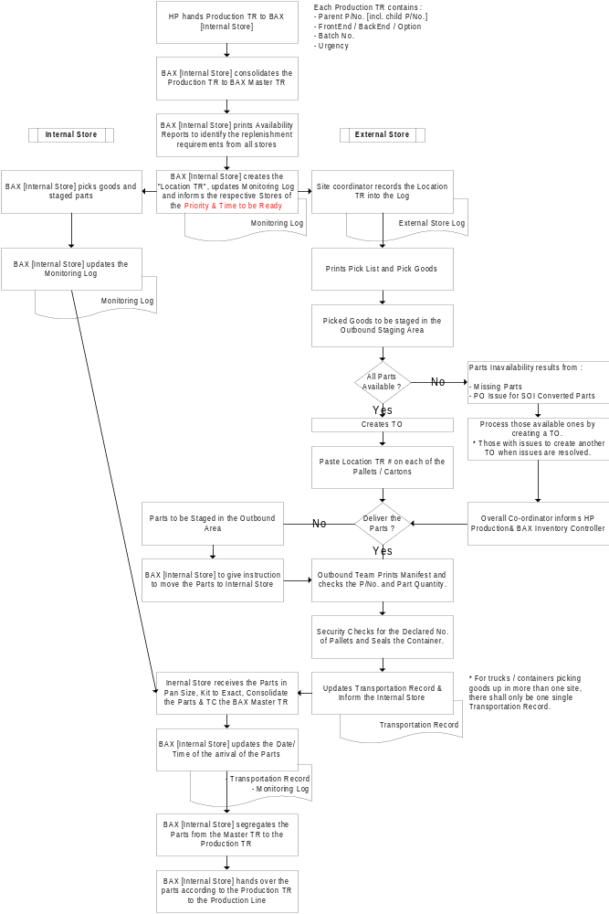

Communication Structure

